**MRCN - 2024**

**Call for Papers**

**Special Session on**

**“Edge Cloud Assisted Smart IOT Application in Health Care Monitoring and Agriculture”**

**Session Chair(s):**

Dr. Kirti Shukla, Associate Professor - CSE, IILM University, Greater Noida.

Dr. Amit Shukla, Assistant Professor - CSE, Galgotias University, Greater Noida.

**EmailID(s):**

Kirti.shukla@iilm.edu, amitshukla@galgotiasuniversity.edu.in

**Aim and Objectives of Session:**

The special session titled "Edge Cloud Assisted Smart IOT Application in Health Care Monitoring and Agriculture" will provide a comprehensive understanding of how edge computing and cloud technologies can be leveraged to enhance IoT applications in healthcare monitoring and agriculture. This session will explore interdisciplinary approaches combining IoT, edge computing, and cloud technologies to solve complex problems in healthcare and agriculture.. Participants will gain insights into the practical applications, potential benefits, and ethical considerations of these technologies, presented by leading experts from academia, industry, and policy-making. This comprehensive session aims to provide a holistic understanding of how AI is revolutionizing diverse sectors and shaping the future of our society.

**Topics of Interest:**

Topics to be discussed in this special session include (but are not limited to) the following:

* Edge Computing in IoT
* **Cloud Integration**
* Healthcare Monitoring
* Agriculture Applications
* Data Management and Analytics
* Security and Privacy
* Case Studies and Real-World Applications
* Future Trends and Emerging Technologies
* Interdisciplinary Approaches
* Standards and Regulations

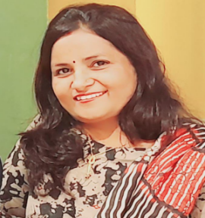

Dr Kirti Shukla is associated with IILM University, Greater Noida since November 2023 as an Associate Professor in School of Computer Science and Engineering .She has more than 18 years of teaching experience in the institution of repute. She Earned her Doctorate degree in Computer Science from Banasthali Vidyapith Rajasthan in 2019. Her area of interest includes Computer Network, Distributed Computing and Artificial Intelligence. She has published around 30 research papers in national & international conferences and journals including MDPI, ACM Digital Library, IEEE eXplore, 5 Patents and 2 Books. She has worked as Invited Speaker, Session Chair, Reviewer, Editor, in many Journals and Conferences. She has Completed Innovation Ambassdor Training by MoE innovation Cell & AICTE . She was also Jury member of Toycathon by MoE innovation Cell & AICTE in 2021. She worked in many Committees like E-Cell, Board Of Studies, College Research Commiittee etc. She worked with accrediation team of NAAC, NBA, ARIIA and QS ranking .

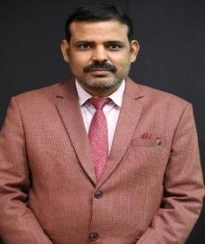

Dr. AMIT SHUKLA  is currently working as Assistant Professor in the School of Computer Science and Engineering. He has a total experience of more than 18 years in teaching. He has been associated with Galgotias University since 2021. His area of interest includes Remote Sensing, Image Processing, Deep Learning,Machine Learning. He has published around 30 research papers in national & international conferences and journals including ACM Digital Library, IEEE eXplore, 5 Patents published & 1 granted and 2 Books. He has worked as Session Chair, Reviewer, Editor, in many Journals and Conferences. He was also Jury member of Toycathon by MoE innovation Cell & AICTE in 2021. He worked in many Committees like E-Cell, Board Of Studies, College Research Commiittee , Time Table & ERP etc. He has worked with accrediation team of NAAC, NBA, ARIIA and QS ranking .

Being a passionate teacher, He believes that teaching is not merely restricted to making the students understand the underlying concepts of a course but also to developing critical thinking and evaluating alternate approaches for problem-solving. He always puts his efforts toward the overall development of his students. He has convened/organized more than 40 co-curricular/Extracurricular events for the benefit of students in the past 5 years.